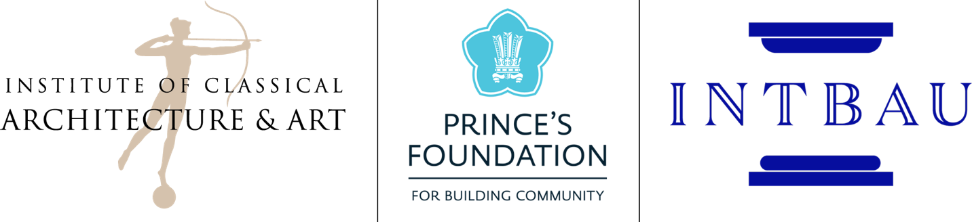

The Award for Emerging Excellence in the Classical Tradition
Application form

Please email this form, along with the supporting documentation, to education@classicist.org by 5pm EST on 31st March 2017.

APPLICATION REQUIREMENT CHECKLIST:

Completed Application Form
Personal Statement (maximum 200 words)
Portfolio: PDF of a maximum of five 11 x 17 sheets (must describe your role and others’ roles, if applicable)
Resume or Curriculum Vitae (maximum two pages)
Letter of Recommendation

All materials, except for the letter of recommendation, are to be submitted together. The letter of recommendation may be submitted separately. Applicants should email all materials as PDFs to education@classicist.org. Hard copy applications will not be accepted.

If you have any questions about this program or the application process, please contact Edith Platten, Director of Education at eplatten@classicist.org or call (212) 730-9646 x 113.

PLEASE NOTE that none of the submitted materials will be returned to the applicant and may be retained by the ICAA.

PERSONAL DATA
Mr./Ms./Mrs.:
Address where you can be contacted:
Street:
City: | State/County: | Zip/Postal code: | Country:
Home Telephone: |  | Business Telephone:
Facsimile: |  | Email Address:
If this address is temporary, until what date can you be reached there?
Permanent Address (if different from above)
Street
City: | State: | Zip Code: | Country:
Telephone:
ACADEMIC HISTORY
Please list all educational institutions or programs attended following high school/\sixth form college.
Name of Institution | Dates Attended | Major Area of Study | Degree & Date
RELATED EXPERIENCE
Please list all relevant work experience, awards, honors, apprenticeships, internships, commissions, etc. with dates.
Position/Award |  | Dates
General Background:  ☐ Architect ☐ Fine Artist ☐ Planner  ☐ Artisan ☐ Historian ☐ Preservationist  ☐ Builder/ Craftsperson ☐ Interior Designer ☐ Student  ☐ Engineer ☐ Landscape Architect ☐Other (Please specify): |  |  |  | ☐ AIA Member  ☐ RIBA Member  Number:
How did you hear about the Award?

